3

Down To Earth (Vic) Co-operative Society Limited

# Application for Funding

**Name of applicant/s:** …………Andrew Wilkinson...........................................................................................

**I hereby apply for a budget of $**…5000.00…..**for project/space:** ……Fuel and maintenance……...........................

**Please describe the purpose and/or philosophy of the project/space**

………Fuel and other item required for maintenance on Woorooma Property

. ……………………………

……….....................………………………………………………………………………………………………………………….

....................………………………………………………………………………………………………………………….............

**Should a budget be granted, it can be accessed in two ways (tick which is applicable):**

**First way:** Spend your own money to a limit within the funding amount approved, then request reimbursement after your project is complete by submitting your receipts/tax invoices. If your project was not ConFest specific, submit within two weeks of project completion. Provide your banking details for reimbursements.

**Second way:** If your application is successful, money will be transferred to you on a DTE debit card. Once your project is complete, submit your receipts/tax invoices in date order

**Do you have a D.T.E Debit Card?** (please circle) **Yes**

If No please contact **finance_group@dte.coop** to arrange for a debit card to be issued to you.

**Applicants for funding must sign the following declaration:**

**I agree to comply with the conditions of the Application for Funding Policy set out overleaf. I agree that the funds will not be used for purposes other than those described by me in this application. I agree to provide receipts/tax invoices as evidence of all expenditure and understand that failure to do so may result in debt recovery and/or legal action.**

**Full Name of applicant** (print) ……On behalf of Andrew Wilkinson….……………………………………......................

**Identification** (eg, Drivers License #)………….………………………..………**PH#**…..………………………......................

**Contact Address/s**……………………………………………………….………………………………...................................

…..…………………………………………………………….**Email** …..……..…………………………………………...............

**Signature of applicant**…………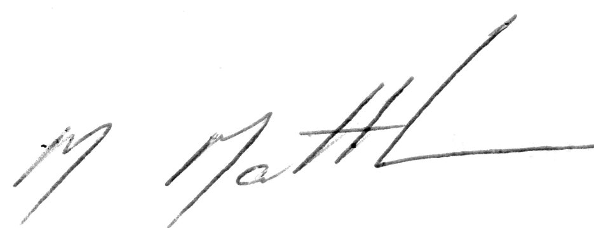.................... **Date 20** /6/ 2023

**Signature of witness** ……………………………………………………………………………………………........................

**Full name of witness** (print) Malcolm Matthews………………………………..................... **PH#**…..…………………………....

Ratified 13/09/18

4

Down To Earth (Vic) Co-operative Society Limited **Application for Funding**

## Details of Intended Uses of Funding

The funding applied for by…Andrew Wilk name of applicant) will be used for the purposes listed on this document. Note: Items over $100 value must be listed individually, and please provide alternate quotes/prices for items over $500 where possible.

The funds cannot be used for any other purpose/s except those detailed by you in this application and approved or adjusted by the relevant committee. All items purchased with DTE funds are and remain the property of the Down To Earth Co-operative Society. Please complete and submit this form with your Funding Application.

If any of the intended expenditures involve a cost for hire/purchase/service to a member of your project/space, DTE, or a ConFester, please give details and include two comparable quotes/estimates:

............................................................................................................................................................................................ ............................................................................................................................................................................................

|  |  |
| --- | --- |
| **Item/Category** | **Expected Cost** |
| Fuel for on site work to DTE Properties |  |
| Maintenance expenses for DTE properties |  |
| Total Budget | 5000.00 |
|  |  |
|  |  |
|  |  |
|  |  |
|  |  |
|  |  |
|  |  |
|  |  |
|  |  |

**Anticipated date for completion of your project**

**Signed**………………Andrew Wilkinson ………………………..… (Applicant Signature) **Date 19/12 2021**

Ratified 13/09/18